CREATION OF TABLE
- In the Application Navigator, search for System Definition → Tables.
- Click New and create a custom table with the following details:
- Label: Institution Details
- Name: u_institution_details
- Extends for : false
- Click Submit.
- Add the following fields to the u_institution_details table:
- Student Roll Number– Auto Number
- Student Name – Reference- User
- Faculty Name – Reference- User
- Branch – Choice (ECE, EEE, CSE)
- Email– String
- Phone Number– String
- Description– Multi String
- Save the Table
- Create multiple records in the Student Records table with different branch values (ECE, EEE, CSE).
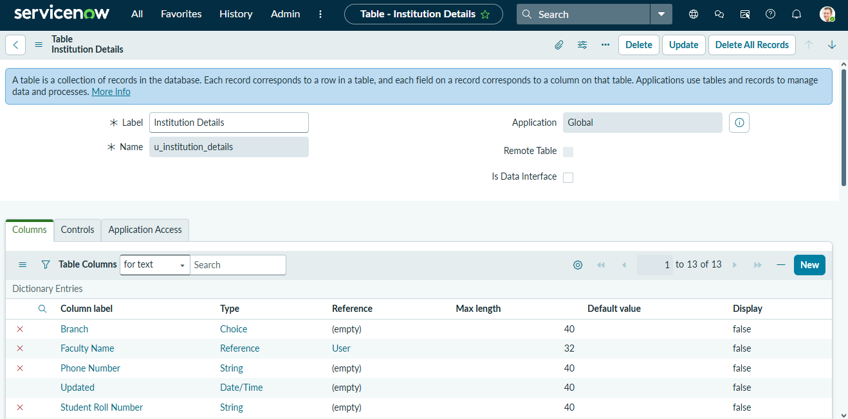
Screenshot – Table Creation
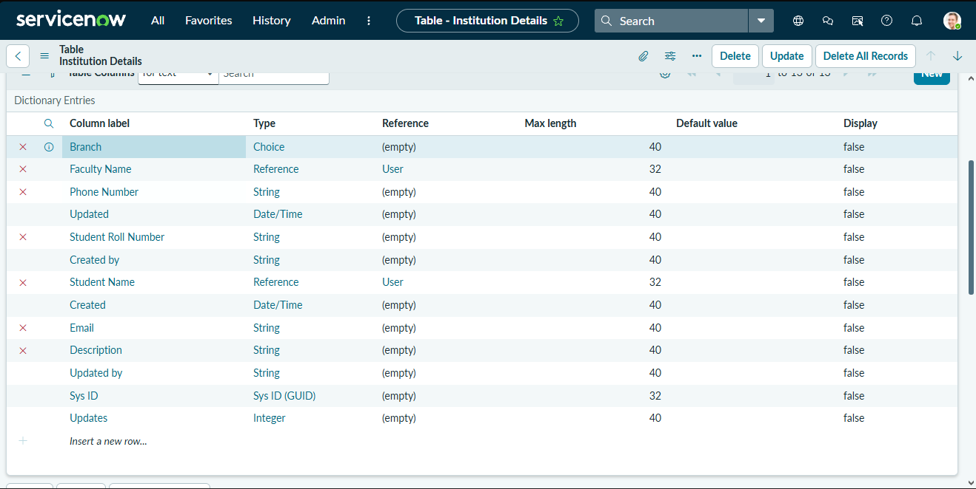
Screenshot – Table Fields

